# Setting up Webstorm

Guide for setting up Webstorm for use with ECMAScript 6 for the [“JavaScript Fundamentals” course @ SoftUni](https://softuni.bg/courses/javascript-basics).

### Setup

1. Startup Webstorm.
2. Create a New Project and setup the project name  
   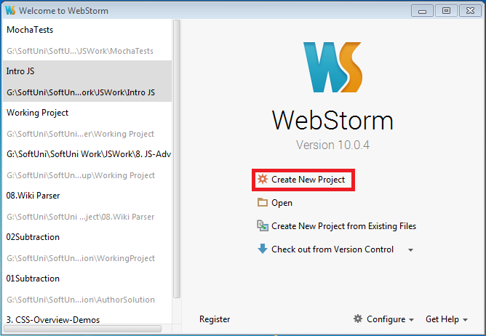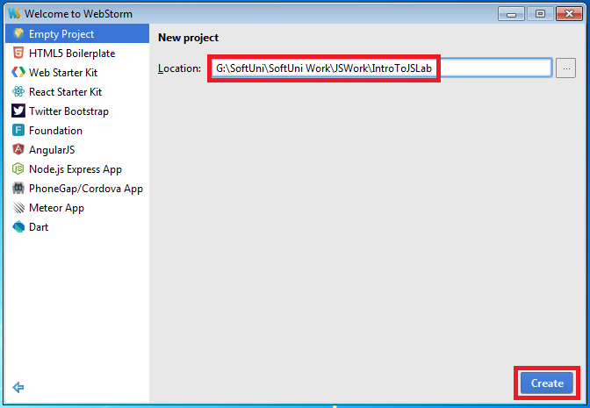
3. Create a new JavaScript file in which to write your code  
   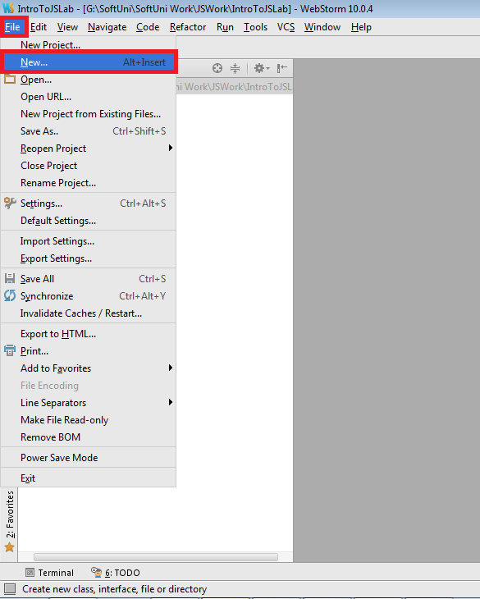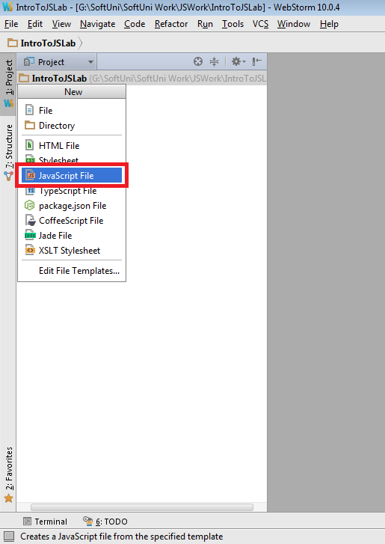  
   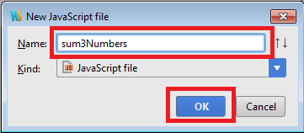
4. Starting to write our code we can see that the “let” statement is marked as incorrect - this happens because we haven’t set up the Language Level of our project to EcmaScript 6  
   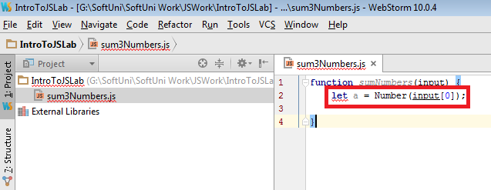
5. Setup the Default Settings for Webstorm, so that all projects start with them by default  
   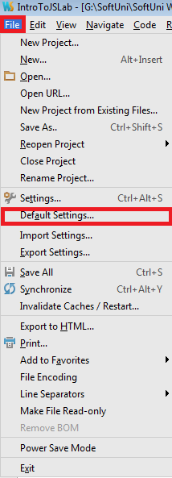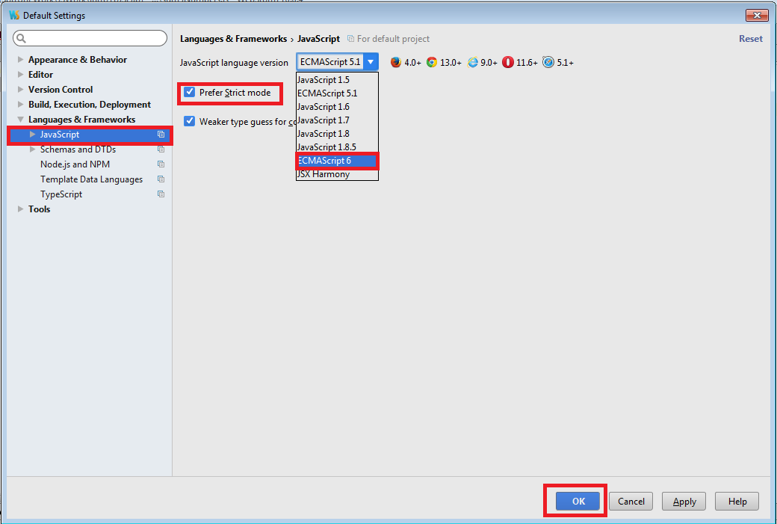
6. You may need to repeat this process for the current Settings as well  
   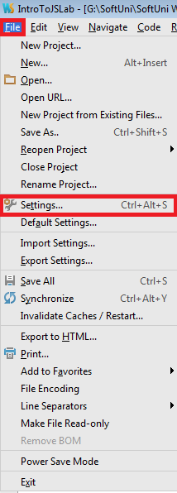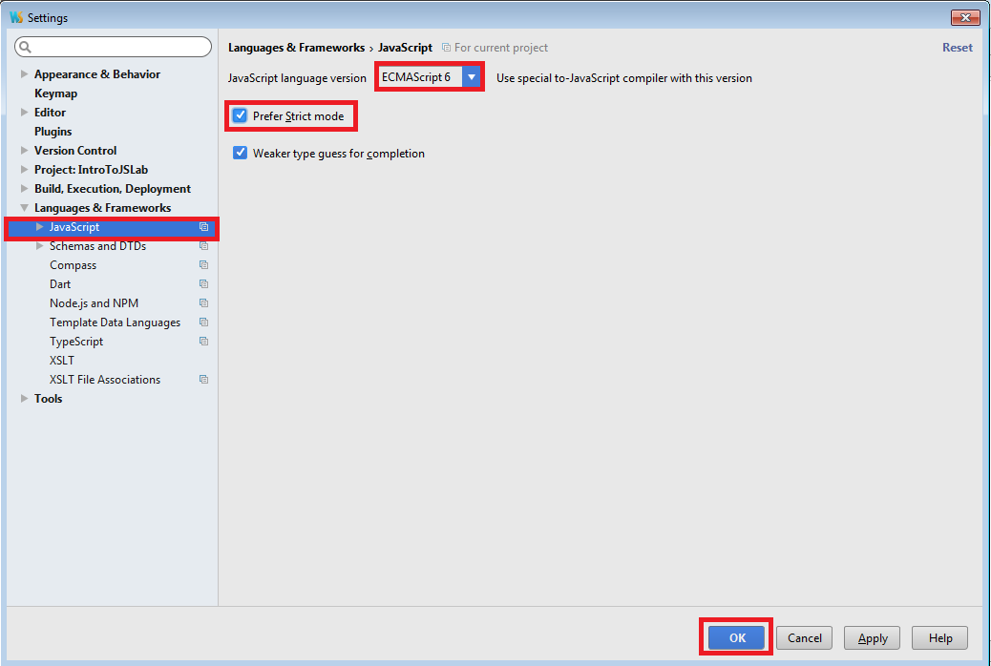
7. We can finish writing our code now  
   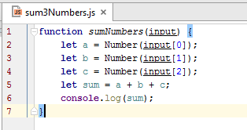
8. If we want to test our code locally with Node, we need to add an extra line to call the function we just wrote with some sample input and then choose Run from the Right-Click menu.  
   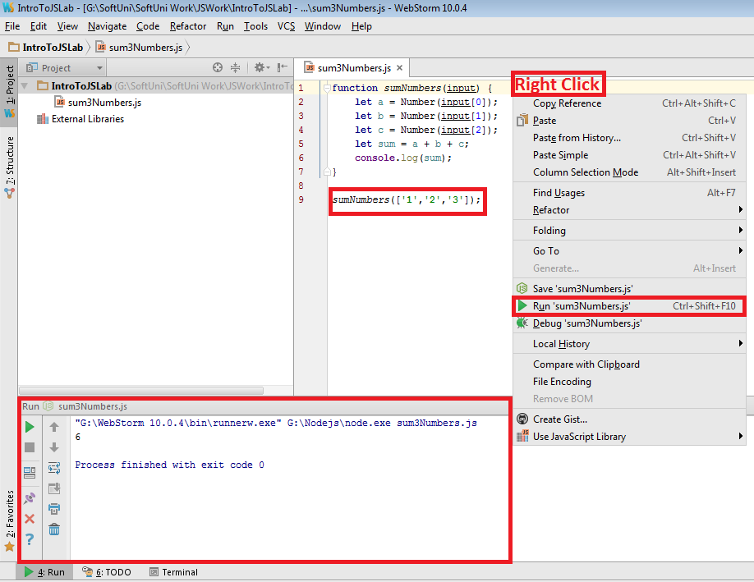
9. Just remember to delete or comment the line calling the method when submitting, because the Judge System expects a single function to be submitted. Submiting more code will cause a Runtime Error.  
   